*The Memorial Service*

*&*

*A Celebration for the*

*Life of Elizabeth (Beth) Thompson Moss*

*August 1st, 1942-February 24th, 2025*

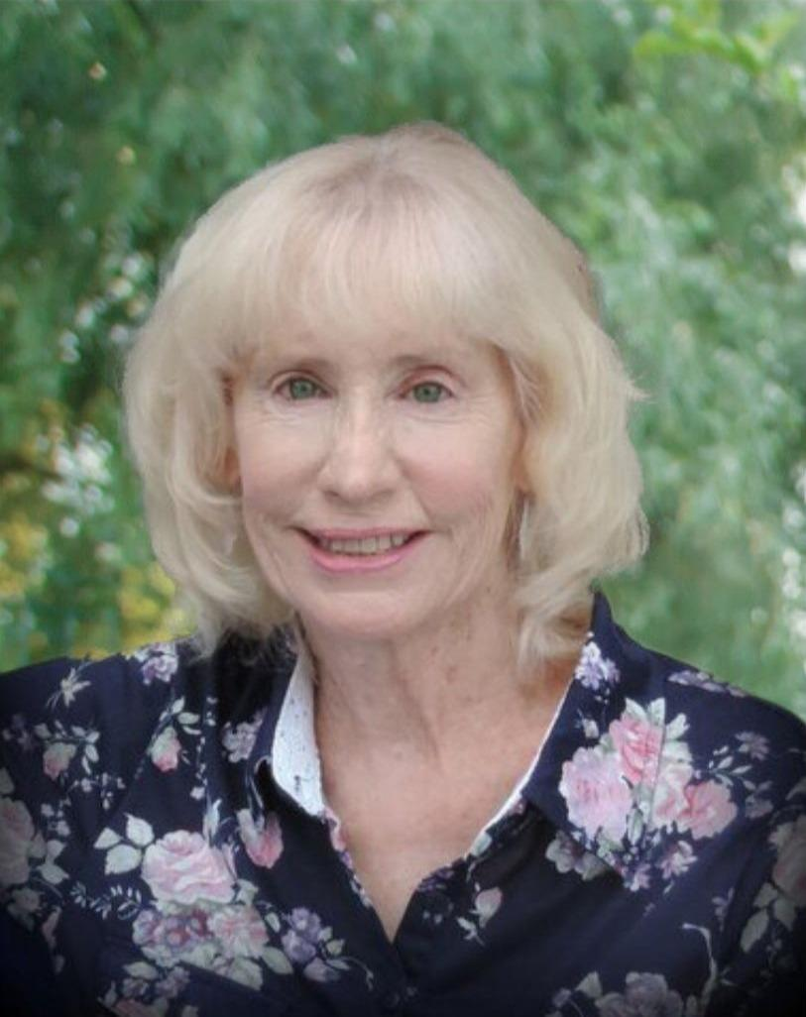

*All Saints’ Episcopal Church*

*Chelmsford, Massachusetts*

11:00 AM

Saturday, March 15th, 2025

**THE ENTRANCE**

Opening Anthems *Book of Common Prayer p. 491*

**Opening Hymn:**“O God, our help in ages past” *Blue Hymnal 680*

I am Resurrection and I am Life, says the Lord. Whoever has faith in me shall have life, even though he dies. And everyone who has life, and has committed himself to me in faith, shall not die for ever.

As for me, I know that my Redeemer lives and that at the last he will stand upon the earth. After my awaking, he will raise me up; and in my body I shall see God. I myself shall see, and my eyes behold him who is my friend and not a stranger.

For none of us has life in himself, and none becomes his own master when he dies. For if we have life, we are alive in the Lord, and if we die, we die in the Lord. So, then, whether we live or die, we are the Lord's possession.

Happy from now on are those who die in the Lord! So it is, says the Spirit, for they rest from their labors.

*Celebrant* The Lord be with you

***People*****And also with you.**

*Celebrant* Let us pray.

*Celebrant says the following Collect*

O God of grace and glory, we remember before you this day our sister Elizabeth. We thank you for giving her to us, her family and friends, to know and to love as a companion on our earthly pilgrimage. In your boundless compassion, console us who mourn. Give us faith to see in death the gate of eternal life, so that in quiet confidence we may continue our course on earth, until, by your call, we are reunited with those who have gone before; through Jesus Christ our Lord. ***Amen****.*

**THE LITURGY OF THE WORD**

**Old Testament Reading Lamentations 3:22-26,31-33**

Josh Prunier son-in-law

*Celebrant* A reading from the second letter of St. Paul to the Corinthians.

***People*****Glory to you, Lord Christ.**

The steadfast love of the Lord never ceases, his mercies never come to an end; they are new every morning; great is your faithfulness. “The Lord is my portion,” says my soul, “therefore I will hope in him.” The Lord is good to those who wait for him, to the soul that seeks him. It is good that one should wait quietly for the salvation of the Lord. For the Lord will not reject forever. Although he causes grief, he will have compassion according to the abundance of his steadfast love; for he does not willingly afflict or grieve anyone.

*Reader*  The Word of the Lord.

***People***  **Thanks be to God**

**Psalm 23** *(Spoken by all)*

1 The LORD is my shepherd; *  
 I shall not be in want.

2 He makes me lie down in green pastures *  
 and leads me beside still waters.

3 He revives my soul *  
 and guides me along right pathways for his Name's sake.

4 Though I walk through the valley of the shadow of death,  
 I shall fear no evil; *  
 for you are with me; your rod and your staff, they comfort me.

5 You spread a table before me in the presence of those   
 who trouble me; *  
 you have anointed my head with oil, and my cup is running over.

6 Surely your goodness and mercy shall follow me all the days  
 of my life, *  
 and I will dwell in the house of the LORD for ever

**New Testament Reading 2 Corinthians 4:16-18**

Ruth Berube-Leach family friend

*Celebrant* A reading from the second letter of St. Paul to the Corinthians.

***People*****Glory to you, Lord Christ.**

So we do not lose heart. Even though our outer nature is wasting away, our inner nature is being renewed day by day. For this slight momentary affliction is preparing us for an eternal weight of glory beyond all measure, because we look not at what can be seen but at what cannot be seen; for what can be seen is temporary, but what cannot be seen is eternal.

*Reader*  The Word of the Lord.

***People***  **Thanks be to God**

**A reading from the Gospel according to St. John 14:1-6**

Do not let your hearts be troubled. Believe in God, believe also in me. In my Father’s house there are many dwelling places. If it were not so, would I have told you that I go to prepare a place for you? And if I go and prepare a place for you, I will come again and will take you to myself, so that where I am, there you may be also. And you know the way to the place where I am going.” Thomas said to him, “Lord, we do not know where you are going. How can we know the way?” Jesus said to him, “I am the way, and the truth, and the life. No one comes to the Father except through me.”

*Celebrant* The Gospel of the Lord

***People*** **Praise to you, Lord Christ**.

**Family Remarks:** Brendan and Adam, Grandsons of Beth

Diane and Cathy, Daughters of Elizabeth

**Homily** The Rev. Sean Maloney

**Apostles’ Creed** *BCP p. 496*

In the assurance of eternal life given at Baptism, let us proclaim our faith and say,

*Celebrant and People*

**I believe in God, the Father almighty,  
creator of heaven and earth.  
  
I believe in Jesus Christ, his only Son, our Lord.  
He was conceived by the power of the Holy Spirit  
and born of the Virgin Mary.  
He suffered under Pontius Pilate,  
was crucified, died, and was buried.  
He descended to the dead.  
On the third day he rose again.  
He ascended into heaven,  
and is seated at the right hand of the Father.  
He will come again to judge the living and the dead.  
I believe in the Holy Spirit,  
 the holy catholic Church,  
the communion of saints,  
the forgiveness of sins,  
 the resurrection of the body,  
and the life everlasting. *Amen.***

**Prayers of the People**

For our sister Beth, let us pray to our Lord Jesus Christ who said, "I am Resurrection and I am Life."

Lord, you consoled Martha and Mary in their distress; draw near to us who mourn for Beth, and dry the tears of those who weep.  
***Hear us, Lord.***

You wept at the grave of Lazarus, your friend; comfort us in our sorrow.  
***Hear us, Lord.***

You raised the dead to life; give to our sister eternal life.  
***Hear us, Lord.***

You promised paradise to the thief who repented; bring our sister to the joys of heaven.  
***Hear us, Lord.***

Our sister was washed in Baptism and anointed with the Holy Spirit; give her fellowship with all your saints.  
***Hear us, Lord.***

She was nourished with your Body and Blood; grant her a place at the table in your heavenly kingdom.  
***Hear us, Lord.***

Comfort us in our sorrows at the death of our sister; let our faith be our consolation, and eternal life our hope.

*Silence may be kept.*

*The Celebrant concludes*

Father of all, we pray to you for Beth, and for all those whom we love but see no longer. Grant to them eternal rest. Let light perpetual shine upon them. May her soul and the souls of all the departed, through the mercy of God, rest in peace.  
***Amen.***

**The Peace**

*Celebrant* The Peace of the Lord be always with you.

***People*** **And also with you.**

## **THE HOLY COMMUNION**

**Offertory Anthem:** Amazing Grace*Blue Hymnal 671*

**The Great Thanksgiving: Eucharistic Prayer B** *BCP p. 367*

*Celebrant*The Lord be with you.

***People* And also with you.**

*Celebrant*Lift up your hearts.

***People* We lift them to the Lord.**

*Celebrant*Let us give thanks to the Lord our God.

***People* It is right to give him thanks and praise.**

*Then, facing the Holy Table, the Celebrant proceeds*

It is right, and a good and joyful thing, always and everywhere to give thanks to you, Father Almighty, Creator of heaven and earth. Through Jesus Christ our Lord; who rose victorious from the dead, and comforts us with the blessed hope of everlasting life. For to your faithful people, O Lord, life is changed, not ended; and when our mortal body lies in death, there is prepared for us a dwelling place eternal in the heavens.

Therefore we praise you, joining our voices with Angels and Archangels and with all the company of heaven, who for ever sing this hymn to proclaim the glory of your name.

*Celebrant and People*

**Sanctus** *(Spoken)*

**Holy, holy, holy Lord, God of power and might,**

**heaven and earth are full of your glory.**

**Hosanna in the highest.**

**Blessed is he who comes in the name of the Lord.**

**Hosanna in the highest.**

*The people stand or kneel.*

*Then the Celebrant continues*

We give thanks to you, O God, for the goodness and love which you have made known to us in creation; in the calling of Israel to be your people; in your Word spoken through the prophets; and above all in the Word made flesh, Jesus, your Son. For in these last days you sent him to be incarnate from the Virgin Mary, to be the Savior and Redeemer of the world. In him, you have delivered us from evil, and made us worthy to stand before you. In him, you have brought us out of error into truth, out of sin into righteousness, out of death into life.

On the night before he died for us, our Lord Jesus Christ took bread; and when he had given thanks to you, he broke it, and gave it to his disciples, and said, "Take, eat: This is my Body, which is given for you. Do this for the remembrance of me."

After supper he took the cup of wine; and when he had given thanks, he gave it to them, and said, "Drink this, all of you: This is my Blood of the new Covenant, which is shed for you and for many for the forgiveness of sins. Whenever you drink it, do this for the remembrance of me."

Therefore, according to his command, O Father,

*Celebrant and People*

**We remember his death,  
We proclaim his resurrection,  
We await his coming in glory;**

*The Celebrant continues*

And we offer our sacrifice of praise and thanksgiving to you, O Lord of all; presenting to you, from your creation, this bread and this wine.

We pray you, gracious God, to send your Holy Spirit upon these gifts that they may be the Sacrament of the Body of Christ and his Blood of the new Covenant. Unite us to your Son in his sacrifice, that we may be acceptable through him, being sanctified by the Holy Spirit. In the fullness of time, put all things in subjection under your Christ, and bring us to that heavenly country where, with Carolyn and all your saints, we may enter the everlasting heritage of your sons and daughters; through Jesus Christ our Lord, the firstborn of all creation, the head of the Church, and the author of our salvation.

By him, and with him, and in him, in the unity of the Holy Spirit all honor and glory is yours, Almighty Father, now and for ever. ***Amen****.*

And now, as our Savior Christ has taught us, we are bold to say,

*People and Celebrant*

**Our Father, who art in heaven, hallowed be thy Name,**

**thy kingdom come, thy will be done,**

**on earth as it is in heaven.**

**Give us this day our daily bread.**

**And forgive us our trespasses,**

**as we forgive those who trespass against us.**

**And lead us not into temptation, but deliver us from evil.**

**For thine is the kingdom, and the power, and the glory,**

**for ever and ever. *Amen.***

**The Breaking of the Bread**

*Celebrant* Alleluia. Christ our Passover is sacrificed for us;

***People***  **Therefore let us keep the feast. Alleluia**.

*Celebrant Whoever you are, wherever you are on your journey of faith,*

*you are welcome to receive the communion of Christ.*

*Non-wheat bread is available at communion for those who are*

*gluten intolerant. Please ask the server for a rice wafer host.*

**Communion Music:** I am the Bread of Life *Blue Hymnal 335*

**Post-Communion Prayer** *(said together)* *BCP p. 498*

**Almighty God, we thank you that in your great love you have fed us with the spiritual food and drink of the Body and Blood of your Son Jesus Christ, and have given us a foretaste of your heavenly banquet. Grant that this Sacrament may be to us a comfort in affliction, and a pledge of our inheritance in that kingdom where there is no death, neither sorrow nor crying, but the fullness of joy with all your saints; through Jesus Christ our Savior. *Amen.***

## **THE COMMENDATION**

**Commendation Sentence:**  *BCP p. 499*

*Celebrant* Give rest, O Christ, to your servant with your saints,  
***People where sorrow and pain are no more, neither sighing, but life everlasting.***

*Celebrant*  You only are immortal, the creator and maker of mankind; and we are mortal, formed of the earth, and to earth shall we return. For so did you ordain when you created me, saying, "You are dust, and to dust you shall return." All of us go down to the dust; yet even at the grave we make our song: Alleluia, alleluia, alleluia.

***People Give rest, O Christ, to your servant with your saints, where sorrow and pain are no more, neither sighing, but life everlasting****.*

*The Celebrant, facing the body, says*

Into your hands, O merciful Savior, we commend your servant Beth. Acknowledge, we humbly beseech you, a sheep of your own fold, a lamb of your own flock, a sinner of your own redeeming. Receive her into the arms of your mercy, into the blessed rest of everlasting peace, and into the glorious company of the saints in light. ***Amen.***

**Recessional “**Immortal, invisible, God only wise” *Blue Hymnal 423*

**Blessing & Dismissal**

*Celebrant* Let us go forth in the name of Christ.

***People***  **Thanks be to God**.

… … … … … … … … … … … … … … … …

**STATEMENT OF INCLUSION FOR ALL SAINTS’ PARISH**

All Saints' Episcopal Church welcomes all people who seek the love of God without regard to ability, age, color, economic circumstance, ethnic background, family configuration, gender, nationality, or sexual orientation.

We promise to "seek and to serve Christ in all persons, …strive for justice and peace among all people, and respect the dignity of every human being.” (From the Baptismal Covenant).

**PARTICIPANTS**

Clergy The Rev. Sean Maloney

Organist Maggie Marshall

**My Journey**

**Wings on my soul**

**Will take flight,**

**Moving through darkness**

**Cascading into light**

**Here**

**I breathe it all in**

**A continuing journey,**

**Joys and disappointments,**

**Laughter and tears,**

**Confidence and fears.**

**There**

**Whispers from spirit**

**Their wisdom is mine to hold.**

**Knowledge of the unknown,**

**Messages to be told.**

**Be aware! Believe!**

**Everywhere**

**Beyond my thinking and being,**

**I feel a power in motion.**

**Brightness, happiness and peace,**

**Surrounding my existence.**

**So much is unexplained.**

**Does it make sense?**

**Does it HAVE to?**

**Here, there and everywhere, like**

**Today, tomorrow and Always.**

**My life on a journey,**

**A soul with wings.**

**Written in an airport while waiting for my flight to**

**Phoenix, AZ - August 2011**

