### The Sixth Sunday after Epiphany

### 10:00 AM + February 16, 2025

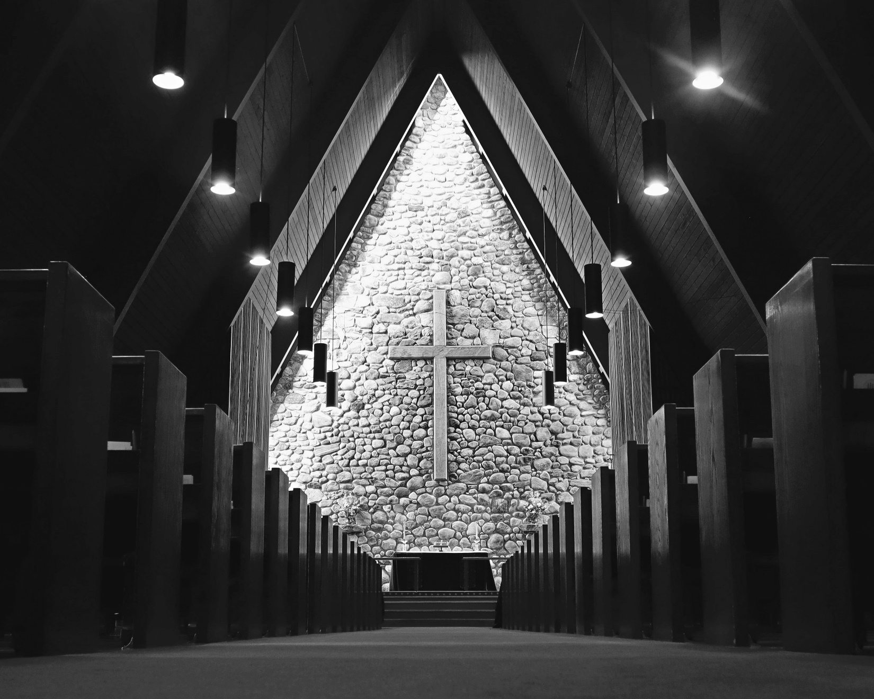

Welcome!  
You are invited to participate fully in our worship. Whoever you are, wherever you are on your journey of faith, welcome!

## The Holy Eucharist: Rite Two

## The Word of God

**Prelude:**Cloches Marcel Fournier (1863-1947)

**Opening Hymn:** “Immortal, invisible, God only wise” Blue Hymnal 423

*Celebrant:* Blessed be God: Father, Son, and Holy Spirit.

*People:* **And blessed be God’s kingdom, now and for ever. Amen.**

*Celebrant:* Almighty God, to you all hearts are open, all desires known, and from you no secrets are hid: Cleanse the thoughts of our hearts by the inspiration of your Holy Spirit, that we may perfectly love you, and worthily magnify your holy Name; through Christ our Lord. **Amen.**

Gloria Blue Hymnal S 280

**Glory to God in the highest,**

**and peace to his people on earth.**

**Lord God, heavenly King, almighty God and Father,**

**we worship you, we give you thanks,**

**we praise you for your glory.**

**Lord Jesus Christ, only Son of the Father,**

**Lord God, Lamb of God, you take away the sin of the world:**

**have mercy on us;**

**you are seated at the right hand of the Father:**

**receive our prayer.**

**For you alone are the Holy One,**

**you alone are the Lord, you alone are the Most High,**

**Jesus Christ, with the Holy Spirit,**

**in the glory of God the Father. Amen.**

*Celebrant:* The Lord be with you.

*People:* **And also with you.**

*Celebrant:* Let us pray.

The Collect *Said in unison*

**O God, the strength of all who put their trust in you: Mercifully accept our prayers; and because in our weakness we can do nothing good without you, give us the help of your grace, that in keeping your commandments we may please you both in will and deed; through Jesus Christ our Lord, who lives and reigns with you and the Holy Spirit, one God, for ever and ever. Amen.**

**A Reading from the Prophet Jeremiah 17:5-10**

Thus says the Lord:

Cursed are those who trust in mere mortals and make mere flesh their strength, whose hearts turn away from the Lord.

They shall be like a shrub in the desert, and shall not see when relief comes.

They shall live in the parched places of the wilderness, in an uninhabited salt land.

Blessed are those who trust in the Lord, whose trust is the Lord.

They shall be like a tree planted by water, sending out its roots by the stream.

It shall not fear when heat comes, and its leaves shall stay green; in the year of drought it is not anxious, and it does not cease to bear fruit.

The heart is devious above all else; it is perverse--who can understand it?

I the Lord test the mind and search the heart, to give to all according to their ways, according to the fruit of their doings.

*Reader:* The Word of the Lord

*People:* **Thanks be to God**

**Psalm 1**

1 Happy are they who have not walked in the counsel of the wicked, *  
nor lingered in the way of sinners,  
nor sat in the seats of the scornful!

2 Their delight is in the law of the Lord, *  
and they meditate on his law day and night.

3 They are like trees planted by streams of water,  
bearing fruit in due season, with leaves that do not wither; *  
everything they do shall prosper.

4 It is not so with the wicked; *  
they are like chaff which the wind blows away.

5 Therefore the wicked shall not stand upright when judgment comes, *  
nor the sinner in the council of the righteous.

6 For the Lord knows the way of the righteous, *  
but the way of the wicked is doomed.

**A reading from the first letter of St. Paul to the**

**Corinthians 15:12-20**

Now if Christ is proclaimed as raised from the dead, how can some of you say there is no resurrection of the dead? If there is no resurrection of the dead, then Christ has not been raised; and if Christ has not been raised, then our proclamation has been in vain and your faith has been in vain. We are even found to be misrepresenting God, because we testified of God that he raised Christ--whom he did not raise if it is true that the dead are not raised. For if the dead are not raised, then Christ has not been raised. If Christ has not been raised, your faith is futile and you are still in your sins. Then those also who have died in Christ have perished. If for this life only we have hoped in Christ, we are of all people most to be pitied.

But in fact Christ has been raised from the dead, the first fruits of those who have died.

*Reader:* The Word of the Lord

*People:* **Thanks be to God**

**Sequence Hymn:** “We know that Christ is raised” Blue Hymnal 296

**A reading from the Gospel according to St. Luke 6:17-26**

*People’s response before the Gospel* **Glory to you, Lord Christ.**

Jesus came down with the twelve apostles and stood on a level place, with a great crowd of his disciples and a great multitude of people from all Judea, Jerusalem, and the coast of Tyre and Sidon. They had come to hear him and to be healed of their diseases; and those who were troubled with unclean spirits were cured. And all in the crowd were trying to touch him, for power came out from him and healed all of them.

Then he looked up at his disciples and said:

“Blessed are you who are poor, for yours is the kingdom of God.

“Blessed are you who are hungry now, for you will be filled.

“Blessed are you who weep now, for you will laugh.

“Blessed are you when people hate you, and when they exclude you, revile you, and defame you on account of the Son of Man. Rejoice in that day and leap for joy, for surely your reward is great in heaven; for that is what their ancestors did to the prophets."

"But woe to you who are rich, for you have received your consolation.

"Woe to you who are full now, for you will be hungry.

"Woe to you who are laughing now, for you will mourn and weep.

"Woe to you when all speak well of you, for that is what their ancestors did to the false prophets."

People’s response after the Gospel  **Praise to you, Lord Christ.**

The Sermon Rev. Sean Maloney

The Nicene Creed *Spoken by all, standing.*

**We believe in one God, the Father, the Almighty, maker of heaven and earth, of all that is, seen and unseen.**

**We believe in one Lord, Jesus Christ, the only Son of God, eternally begotten of the Father, God from God, Light from Light, true God from true God, begotten, not made, of one Being with the Father. Through him all things were made. For us and for our salvation he came down from heaven: by the power of the Holy Spirit he became incarnate from the Virgin Mary, and was made man. For our sake he was crucified under Pontius Pilate; he suffered death and was buried. On the third day he rose again in accordance with the Scriptures; he ascended into heaven and is seated at the right hand of the Father. He will come again in glory to judge the living and the dead, and his kingdom will have no end.**

**We believe in the Holy Spirit, the Lord, the giver of life, who proceeds from the Father and the Son. With the Father and the Son, he is worshiped and glorified. He has spoken through the Prophets.**

**We believe in one holy catholic and apostolic Church. We acknowledge one baptism for the forgiveness of sins. We look for the resurrection of the dead, and the life of the world to come. Amen.**

Prayers of the People – [from Hear Our Prayer: Prayers of the People for the Revised Common Lectionary] *The Leader and People pray responsively*

Let us pray, turning our hearts toward the one who makes our desert hearts bloom with the flowers of hope saying, Lord in your mercy, **hear our prayer.**

Engrave our hearts with your living word of love, that we might listen and turn to you. Lord in your mercy, **hear our prayer.**

Deepen the life of your church, giving it a will to serve the world in your name, and a spirit of welcome that draws all those who hunger to your table. Lord in your mercy, **hear our prayer.**

Give your blessing of courage and truth to those who hold authority in our cities, towns, states, and countries and to those who hold authority in our churches, workplaces, and lives. Lord in your mercy, **hear our prayer.**

The world cries out in despair and desolation. Send your love to heal the brokenness that has become a desert place in our time. Lord in your mercy, **hear our prayer.**

Quench the thirst of those who long for healing, cure, and reconciliation. Be with those who suffer in body, mind, and spirit, and comfort those who anxiously await a word of hope. [Especially we pray for *prayer list.*] Lord in your mercy, **hear our prayer**.

Bring your promise of life in fullness to those who struggle, to those who are oppressed and persecuted, and to those in any kind of need. Lord in your mercy, **hear our prayer.**

Hold in your care those who have died and welcome us into your eternal arms when our time comes, and let us all rise together in your new age. Lord in your mercy, **hear our prayer.**

In the hope of the life to come and in communion with those who have died, we look to the day where with your son and the Holy Spirit we might come to dwell in your verdant kingdom. **Amen.**

## Confession of Sin

*Celebrant:* Let us confess our sins to God. (Silence may be kept.)

**God of all mercy, we confess that we have sinned against you, opposing your will in our lives. We have denied your goodness in each other, in ourselves, and in the world you have created. We repent of the evil that enslaves us, the evil we have done, and the evil done on our behalf.**

**Forgive, restore, and strengthen us through our Savior Jesus Christ, that we may abide in your love and serve only your will. Amen.**

**Absolution**

Almighty God have mercy on you, forgive you all your sins through the grace of Jesus Christ, strengthen you in all goodness, and by the power of the Holy Spirit keep you in eternal life. Amen.

The Peace *All stand*

*Celebrant:* The peace of the Lord be always with you.

*People:* **And also with you**.

## Announcements:

**The Holy Communion**

## The Great Thanksgiving - *Eucharistic Prayer 1*

**Offertory Anthem:** Bell Choir

*Eucharistic Prayer 1*

*Celebrant* The Lord be with you.

*People* **And also with you.**

*Celebrant*  Lift up your hearts.

*People* **We lift them to the Lord.**

*Celebrant* Let us give thanks to the Lord our God.

*People*  **It is right to give our thanks and praise.**

Celebrant

It is truly right, and good and joyful,

to give you thanks, all-holy God,

source of life and fountain of mercy.

You have filled us and all creation with your blessing

and fed us with your constant love;

you have redeemed us in Jesus Christ

and knit us into one body.

Through your Spirit you replenish us

and call us to fullness of life.

Therefore, joining with Angels and Archangels

and with the faithful of every generation,

we lift our voices with all creation as we sing (say):

Sanctus: Blue Hymnal S 129

*Celebrant and People*

**Holy, holy, holy Lord, God of power and might,**

**heaven and earth are full of your glory.**

**Hosanna in the highest.**

**Blessed is the one who comes in the name of the Lord.**

**Hosanna in the highest.**

Blessed are you, gracious God,

creator of the universe and giver of life.

You formed us in your own image

and called us to dwell in your infinite love.

You gave the world into our care

that we might be your faithful stewards

and show forth your bountiful grace.

But we failed to honor your image

in one another and in ourselves;

we would not see your goodness in the world around us;

and so we violated your creation,

abused one another,

and rejected your love.

Yet you never ceased to care for us,

and prepared the way of salvation for all people.

Through Abraham and Sarah

you called us into covenant with you.

You delivered us from slavery,

sustained us in the wilderness,

and raised up prophets

to renew your promise of salvation.

Then, in the fullness of time,

you sent your eternal Word,

made mortal flesh in Jesus.

Born into the human family,

and dwelling among us,

he revealed your glory.

Giving himself freely to death on the cross,

he triumphed over evil,

opening the way of freedom and life.

On the night before he died for us,

Our Savior Jesus Christ took bread,

and when he had given thanks to you,

he broke it, and gave it to his friends, and said:

“Take, eat:

This is my Body which is given for you.

Do this for the remembrance of me.

As supper was ending, Jesus took the cup of wine,

and when he had given thanks,

he gave it to them, and said:

“Drink this, all of you:

This is my Blood of the new Covenant,

which is poured out for you and for all

for the forgiveness of sins.

Whenever you drink it,

do this for the remembrance of me.”

Therefore we proclaim the mystery of faith:

**Christ has died.**

**Christ is risen.**

**Christ will come again**.

Remembering his death and resurrection,

we now present to you from your creation

this bread and this wine.

By your Holy Spirit may they be for us

the Body and Blood of our Savior Jesus Christ.

Grant that we who share these gifts

may be filled with the Holy Spirit

and live as Christ’s Body in the world.

Bring us into the everlasting heritage

of your daughters and sons,

that with [ ___________ and] all your saints,

past, present, and yet to come,

we may praise your Name for ever.

Through Christ and with Christ and in Christ,

in the unity of the Holy Spirit,

to you be honor, glory, and praise,

for ever and ever. **AMEN.**

And now, as our Savior Christ has taught us, we are bold to say,

**Our Father, who art in heaven, hallowed be thy Name, thy kingdom come, thy will be done, on earth as it is in heaven.**

**Give us this day our daily bread.**

**And forgive us our trespasses,   
as we forgive those who trespass against us.**

**And lead us not into temptation, but deliver us from evil.**

**For thine is the kingdom, and the power, and the glory,   
for ever and ever. Amen.**

## The Breaking of the Bread

Alleluia, Christ our Passover is sacrificed for us;

**Therefore let us keep the feast. Alleluia.**

**Fraction Anthem:** Christ our Passover Blue Hymnal S 155

**Communion Music**

*Celebrant and People*

**Eternal God, heavenly Father, you have graciously accepted us as living members of your Son our Savior Jesus Christ, and you have fed us with spiritual food in the Sacrament of his Body and Blood. Send us now into the world in peace, and grant us strength and courage to love and serve you with gladness and singleness of heart; through Christ our Lord. Amen.**

**Closing Hymn:** “Jesus shall reign where’er the sun” Blue Hymnal 544

## The Dismissal

*Celebrant:* Let us go forth in the name of Christ.

*People:* **Thanks be to God. Alleluia, Alleluia, Alleluia.**

**Postlude:** Fugue in C Dietrich Buxtehude (1637-1707)

## Thank you for joining us today!

if you would like to receive our weekly e-bulletin, please contact the church office (aschurch@allsaintschelmsford.org) To learn more about us, visit https://www.allsaintschelmsford.org or call us at 978 256 5673.