### Third Sunday after the Epiphany

### 10:00 AM + January 26th, 2025

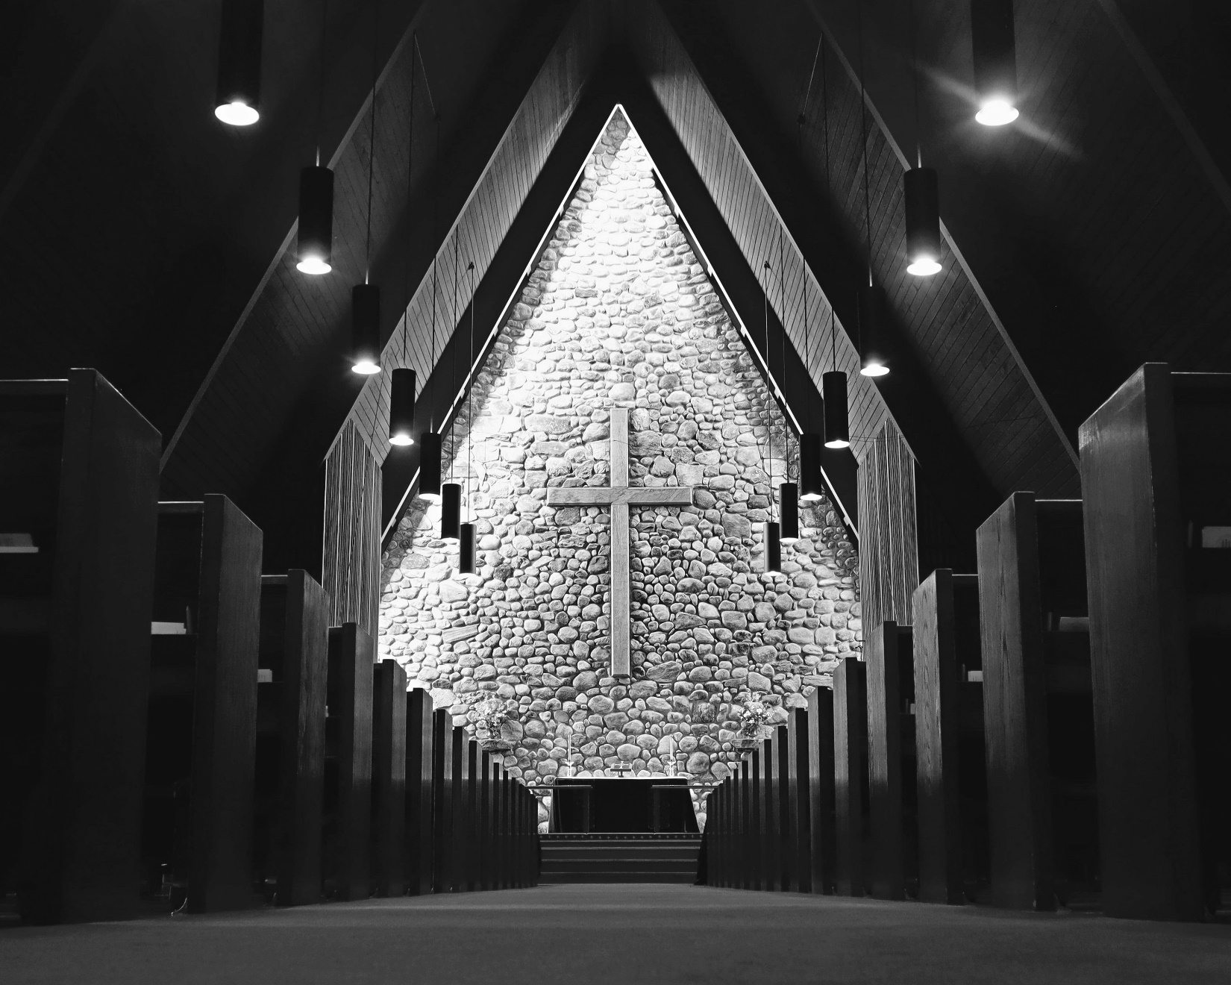

Welcome!  
You are invited to participate fully in our worship. Whoever you are, wherever you are on your journey of faith, welcome!

## The Holy Eucharist: Rite Two

## The Word of God

**Prelude: Christus der ist mein Leben** Johann Walther

**Opening Hymn:** “Hail to the Lord’s anointed” Blue Hymnal 616

*Celebrant:* Blessed be God: Father, Son, and Holy Spirit.

*People:* **And blessed be God’s kingdom, now and for ever. Amen.**

*Celebrant:* Almighty God, to you all hearts are open, all desires known, and from you no secrets are hid: Cleanse the thoughts of our hearts by the inspiration of your Holy Spirit, that we may perfectly love you, and worthily magnify your holy Name; through Christ our Lord. **Amen.**

Gloria: Glory to God *Blue Hymnal S 280*

**Glory to God in the highest,**

**and peace to his people on earth.**

**Lord God, heavenly King, almighty God and Father,**

**we worship you, we give you thanks,**

**we praise you for your glory.**

**Lord Jesus Christ, only Son of the Father,**

**Lord God, Lamb of God, you take away the sin of the world:**

**have mercy on us;**

**you are seated at the right hand of the Father:**

**receive our prayer.**

**For you alone are the Holy One,**

**you alone are the Lord, you alone are the Most High,**

**Jesus Christ, with the Holy Spirit,**

**in the glory of God the Father. Amen.**

*Celebrant:* The Lord be with you.

*People:* **And also with you.**

*Celebrant:* Let us pray.

The Collect *Said in unison*

Give us grace, O Lord, to answer readily the call of our Savior Jesus Christ and proclaim to all people the Good News of his salvation, that we and the whole world may perceive the glory of his marvelous works; who lives and reigns with you and the Holy Spirit, one God, for ever and ever. **Amen.**

**A Reading from the Prophet Nehemiah 8:1-3, 5-6, 8-10**

All the people of Israel gathered together into the square before the Water Gate. They told the scribe Ezra to bring the book of the law of Moses, which the Lord had given to Israel. Accordingly, the priest Ezra brought the law before the assembly, both men and women and all who could hear with understanding. This was on the first day of the seventh month. He read from it facing the square before the Water Gate from early morning until midday, in the presence of the men and the women and those who could understand; and the ears of all the people were attentive to the book of the law. And Ezra opened the book in the sight of all the people, for he was standing above all the people; and when he opened it, all the people stood up. Then Ezra blessed the Lord, the great God, and all the people answered, "Amen, Amen," lifting up their hands. Then they bowed their heads and worshiped the Lord with their faces to the ground. So they read from the book, from the law of God, with interpretation. They gave the sense, so that the people understood the reading.

And Nehemiah, who was the governor, and Ezra the priest and scribe, and the Levites who taught the people said to all the people, "This day is holy to the Lord your God; do not mourn or weep." For all the people wept when they heard the words of the law. Then he said to them, "Go your way, eat the fat and drink sweet wine and send portions of them to those for whom nothing is prepared, for this day is holy to our Lord; and do not be grieved, for the joy of the Lord is your strength."

*Celebrant:* The Word of the Lord

*People:* **Thanks be to God**

**Psalm 19**

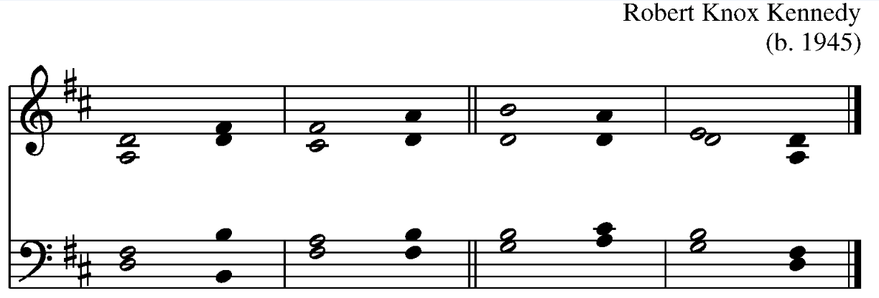  
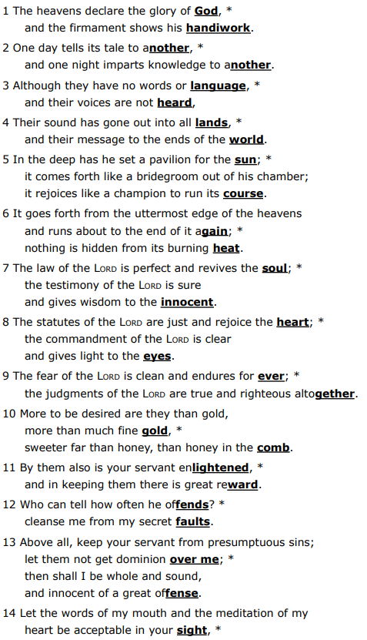

**A reading from the first letter of St. Paul to the Corinthians 12:12-31a**

Just as the body is one and has many members, and all the members of the body, though many, are one body, so it is with Christ. For in the one Spirit we were all baptized into one body--Jews or Greeks, slaves or free--and we were all made to drink of one Spirit.

Indeed, the body does not consist of one member but of many. If the foot would say, "Because I am not a hand, I do not belong to the body," that would not make it any less a part of the body. And if the ear would say, "Because I am not an eye, I do not belong to the body," that would not make it any less a part of the body. If the whole body were an eye, where would the hearing be? If the whole body were hearing, where would the sense of smell be? But as it is, God arranged the members in the body, each one of them, as he chose. If all were a single member, where would the body be? As it is, there are many members, yet one body. The eye cannot say to the hand, "I have no need of you," nor again the head to the feet, "I have no need of you." On the contrary, the members of the body that seem to be weaker are indispensable, and those members of the body that we think less honorable we clothe with greater honor, and our less respectable members are treated with greater respect; whereas our more respectable members do not need this. But God has so arranged the body, giving the greater honor to the inferior member, that there may be no dissension within the body, but the members may have the same care for one another. If one member suffers, all suffer together with it; if one member is honored, all rejoice together with it.

Now you are the body of Christ and individually members of it. And God has appointed in the church first apostles, second prophets, third teachers; then deeds of power, then gifts of healing, forms of assistance, forms of leadership, various kinds of tongues. Are all apostles? Are all prophets? Are all teachers? Do all work miracles? Do all possess gifts of healing? Do all speak in tongues? Do all interpret? But strive for the greater gifts.

*People:* **Thanks be to God**

**Sequence Hymn:** “Sing Praise to our creator” Blue Hymnal 295

**A reading from the Gospel according to St. Luke 4:14-21**

Jesus, filled with the power of the Spirit, returned to Galilee, and a report about him spread through all the surrounding country. He began to teach in their synagogues and was praised by everyone.

When he came to Nazareth, where he had been brought up, he went to the synagogue on the sabbath day, as was his custom. He stood up to read, and the scroll of the prophet Isaiah was given to him. He unrolled the scroll and found the place where it was written:

"The Spirit of the Lord is upon me,

because he has anointed me  
to bring good news to the poor.

He has sent me to proclaim release to the captives  
and recovery of sight to the blind,  
to let the oppressed go free,

to proclaim the year of the Lord's favor."

And he rolled up the scroll, gave it back to the attendant, and sat down. The eyes of all in the synagogue were fixed on him. Then he began to say to them, "Today this scripture has been fulfilled in your hearing."

*People’s response before the Gospel* **Glory to you, Lord Christ.**

The Sermon Rev. Sean Maloney

The Nicene Creed *Spoken by all, standing.*

**We believe in one God, the Father, the Almighty, maker of heaven and earth, of all that is, seen and unseen.**

**We believe in one Lord, Jesus Christ, the only Son of God, eternally begotten of the Father, God from God, Light from Light, true God from true God, begotten, not made, of one Being with the Father. Through him all things were made. For us and for our salvation he came down from heaven: by the power of the Holy Spirit he became incarnate from the Virgin Mary, and was made man. For our sake he was crucified under Pontius Pilate; he suffered death and was buried. On the third day he rose again in accordance with the Scriptures; he ascended into heaven and is seated at the right hand of the Father. He will come again in glory to judge the living and the dead, and his kingdom will have no end.**

**We believe in the Holy Spirit, the Lord, the giver of life, who proceeds from the Father and the Son. With the Father and the Son, he is worshiped and glorified. He has spoken through the Prophets.**

**We believe in one holy catholic and apostolic Church. We acknowledge one baptism for the forgiveness of sins. We look for the resurrection of the dead, and the life of the world to come. Amen.**

Prayers of the People - from Hear Our Prayer: Prayers of the People for the Revised Common Lectionary, *The Leader and People pray responsively*

Marvelous God who has brought forth many wonderful works, hear pour prayers and answer our needs and hopes as we pray, Lord in your mercy, **hear our prayer.**

Help your church to see its strength in openness and cooperation, help us to forge bonds of mission and ministry with others that your glory might extend across the whole earth. Lord in your mercy, **hear our prayer.**

Let the light of truth and justice shine forth across our nation; may this nation be a place of peace and opportunity for all its people.

Lord in your mercy, **hear our prayer.**

Send your Spirit upon this assembly that this might be place of refuge, a beacon of hope, and a true embodiment of the Good News for our neighbors. Lord in your mercy, **hear our prayer.**

May your holy words guide us in our endeavor to be good stewards of your creation, ensuring its abundance for ourselves and for those to be born. Lord in your mercy, **hear our prayer.**

Lift up the lowly and forgotten, gather the marginalized, and bring liberty to the oppressed that the power of your love might inspire all people. Lord in your mercy, **hear our prayer.**

Bring your healing spirit to bear in the lives of all who suffer from any sickness or infirmary. Let them know wholeness, wellness, and peace.

[Especially we pray for…*prayer* list] Lord in your mercy, **hear our prayer.**

Receive the dying into your loving arms eternally; may we and they some day know you face to face in your coming age.

Lord in your mercy, **hear our prayer.**

Hear the prayers of your people and answer us as you have answered your people across time so that we might feel your presence among us and strengthen us for the call of being agents of your love in the world. **Amen.**

## Confession of Sin

*Celebrant:* Let us confess our sins to God. (Silence may be kept.)

**God of all mercy, we confess that we have sinned against you, opposing your will in our lives. We have denied your goodness in each other, in ourselves, and in the world you have created. We repent of the evil that enslaves us, the evil we have done, and the evil done on our behalf.**

**Forgive, restore, and strengthen us through our Savior Jesus Christ, that we may abide in your love and serve only your will. Amen.**

**Absolution**

Almighty God have mercy on you, forgive you all your sins through the grace of Jesus Christ, strengthen you in all goodness, and by the power of the Holy Spirit keep you in eternal life. Amen.

The Peace *All stand*

*Celebrant:* The peace of the Lord be always with you.

*People:* **And also with you**.

## Announcements:

**The Holy Communion**

## The Great Thanksgiving - *Eucharistic Prayer 1*

**Offertory Anthem:** How beautiful upon the Mountains Words: Isaiah 52:7, Music: John Stainer

*Celebrant* The Lord be with you.

*People* **And also with you.**

*Celebrant*  Lift up your hearts.

*People* **We lift them to the Lord.**

*Celebrant* Let us give thanks to the Lord our God.

*People*  **It is right to give our thanks and praise.**

Celebrant

It is truly right, and good and joyful,

to give you thanks, all-holy God,

source of life and fountain of mercy.

You have filled us and all creation with your blessing

and fed us with your constant love;

you have redeemed us in Jesus Christ

and knit us into one body.

Through your Spirit you replenish us

and call us to fullness of life.

Therefore, joining with Angels and Archangels

and with the faithful of every generation,

we lift our voices with all creation as we sing (say):

Sanctus: Blue Hymnal S 129

*Celebrant and People*

**Holy, holy, holy Lord, God of power and might,**

**heaven and earth are full of your glory.**

**Hosanna in the highest.**

**Blessed is the one who comes in the name of the Lord.**

**Hosanna in the highest.**

Blessed are you, gracious God,

creator of the universe and giver of life.

You formed us in your own image

and called us to dwell in your infinite love.

You gave the world into our care

that we might be your faithful stewards

and show forth your bountiful grace.

But we failed to honor your image

in one another and in ourselves;

we would not see your goodness in the world around us;

and so we violated your creation,

abused one another,

and rejected your love.

Yet you never ceased to care for us,

and prepared the way of salvation for all people.

Through Abraham and Sarah

you called us into covenant with you.

You delivered us from slavery,

sustained us in the wilderness,

and raised up prophets

to renew your promise of salvation.

Then, in the fullness of time,

you sent your eternal Word,

made mortal flesh in Jesus.

Born into the human family,

and dwelling among us,

he revealed your glory.

Giving himself freely to death on the cross,

he triumphed over evil,

opening the way of freedom and life.

On the night before he died for us,

Our Savior Jesus Christ took bread,

and when he had given thanks to you,

he broke it, and gave it to his friends, and said:

“Take, eat:

This is my Body which is given for you.

Do this for the remembrance of me.”

As supper was ending, Jesus took the cup of wine,

and when he had given thanks,

he gave it to them, and said:

“Drink this, all of you:

This is my Blood of the new Covenant,

which is poured out for you and for all

for the forgiveness of sins.

Whenever you drink it,

do this for the remembrance of me.”

Therefore we proclaim the mystery of faith:

**Christ has died.**

**Christ is risen.**

**Christ will come again**.

Remembering his death and resurrection,

we now present to you from your creation

this bread and this wine.

By your Holy Spirit may they be for us

the Body and Blood of our Savior Jesus Christ.

Grant that we who share these gifts

may be filled with the Holy Spirit

and live as Christ’s Body in the world.

Bring us into the everlasting heritage

of your daughters and sons,

that with [ ___________ and] all your saints,

past, present, and yet to come,

we may praise your Name for ever.

Through Christ and with Christ and in Christ,

in the unity of the Holy Spirit,

to you be honor, glory, and praise,

for ever and ever. **AMEN.**

And now, as our Savior Christ has taught us, we are bold to say,

**Our Father, who art in heaven, hallowed be thy Name, thy kingdom come, thy will be done, on earth as it is in heaven.**

**Give us this day our daily bread.**

**And forgive us our trespasses,   
as we forgive those who trespass against us.**

**And lead us not into temptation, but deliver us from evil.**

**For thine is the kingdom, and the power, and the glory,   
for ever and ever. Amen.**

## The Breaking of the Bread

Alleluia, Christ our Passover is sacrificed for us;

**Therefore let us keep the feast. Alleluia.**

**Fraction Anthem:** Christ our Passover Blue Hymnal S 155

**Communion Music:** The Stars Declare His Glory Blue Hymnal 431 Words: Timothy Dudley-Smith, Music: *Aldine; Richard Proulx*

*Celebrant and People*

**Eternal God, heavenly Father, you have graciously accepted us as living members of your Son our Savior Jesus Christ, and you have fed us with spiritual food in the Sacrament of his Body and Blood. Send us now into the world in peace, and grant us strength and courage to love and serve you with gladness and singleness of heart; through Christ our Lord. Amen.**

**Closing Hymn:** “Spread, O spread, thou mighty word” Blue Hymnal 530 (vv. 1-4)

**Postlude:** Voluntary in D William Croft

## The Dismissal

*Celebrant:* Let us go forth in the name of Christ.

*People:* **Thanks be to God. Alleluia, Alleluia, Alleluia.**

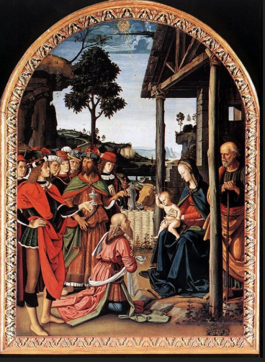

## Thank you for joining us today!

if you would like to receive our weekly e-bulletin, please contact the church office (aschurch@allsaintschelmsford.org) To learn more about us, visit https://www.allsaintschelmsford.org or call us at 978 256 5673.