### Third Sunday of Advent

### 10:00 AM + December 15th, 2024

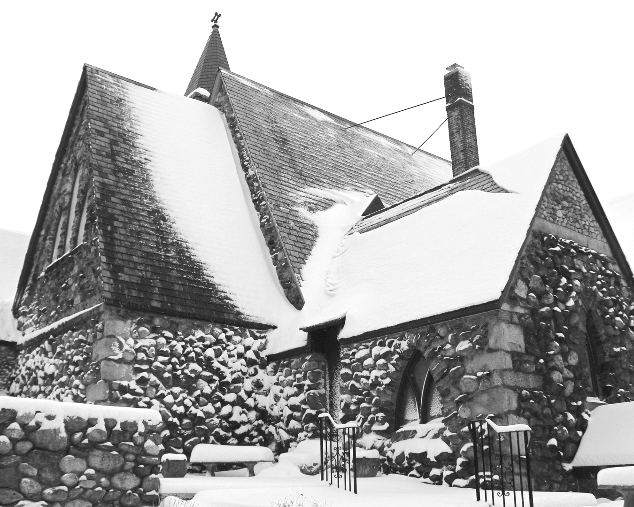

Welcome!  
You are invited to participate fully in our worship. Whoever you are, wherever you are on your journey of faith, welcome!

## The Holy Eucharist: Rite Two

## The Word of God

**Prelude:** Nun komm der Heiden Heiland Pachelbel

***The Lighting of the Advent Wreath***  *to the tune of Away in a Manger*

A candle is burning, a candle of PEACE.

A candle to signal that conflict must cease.

For Jesus is coming to show us the way,

A message of peace humbly laid in the hay.

**Opening Hymn:** “There’s a voice in the wilderness crying” Blue Hymnal 75

*Celebrant: Blessed are you, holy and living One.*

*People:* ***You come to your people and set them free****.*

*Celebrant:* Almighty God, to you all hearts are open, all desires known, and from you no secrets are hid: Cleanse the thoughts of our hearts by the inspiration of your Holy Spirit, that we may perfectly love you, and worthily magnify your holy Name; through Christ our Lord. Amen.

**Kyrie:** Lord, have mercy upon us S91

*Celebrant:* The Lord be with you.

*People:* **And also with you.**

*Celebrant:* Let us pray.

The Collect *Said in unison*

Stir up your power, O Lord, and with great might come among us; and, because we are sorely hindered by our sins, let your bountiful grace and mercy speedily help and deliver us; through Jesus Christ our Lord, to whom, with you and the Holy Spirit, be honor and glory, now and for ever. **Amen.**

**A Reading from the Book of** **Zephaniah 3:14-20**

Sing aloud, O daughter Zion;  
shout, O Israel!

Rejoice and exult with all your heart,  
O daughter Jerusalem!

The Lord has taken away the judgments against you,  
he has turned away your enemies.

The king of Israel, the Lord, is in your midst;  
you shall fear disaster no more.

On that day it shall be said to Jerusalem:

Do not fear, O Zion;  
do not let your hands grow weak.

The Lord, your God, is in your midst,  
a warrior who gives victory;

he will rejoice over you with gladness,  
he will renew you in his love;

he will exult over you with loud singing  
as on a day of festival.

I will remove disaster from you,  
so that you will not bear reproach for it.

I will deal with all your oppressors  
at that time.

And I will save the lame  
and gather the outcast,

and I will change their shame into praise  
and renown in all the earth.

At that time I will bring you home,  
at the time when I gather you;

for I will make you renowned and praised  
among all the peoples of the earth,

when I restore your fortunes  
before your eyes, says the Lord.

## *Celebrant:* The Word of the Lord

## *People:* Thanks be to God

**Canticle 9   Page 86, BCP The First Song of Isaiah    *Ecce Deus***

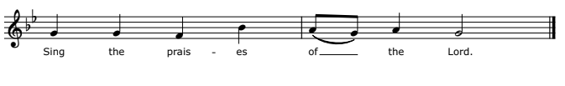

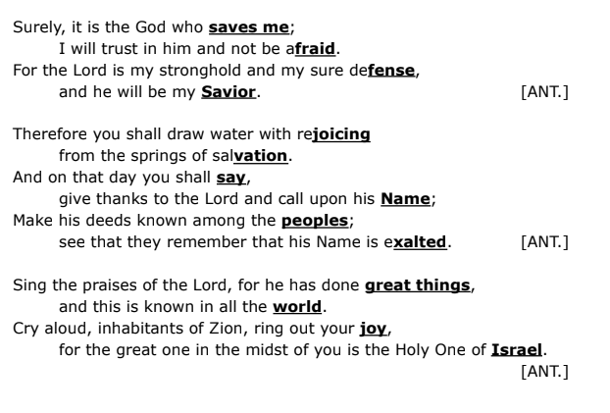

**A Reading from the Book of Philippians 4:4-7**

Rejoice in the Lord always; again I will say, Rejoice. Let your gentleness be known to everyone. The Lord is near. Do not worry about anything, but in everything by prayer and supplication with thanksgiving let your requests be made known to God. And the peace of God, which surpasses all understanding, will guard your hearts and your minds in Christ Jesus.

## *Celebrant:* The Word of the Lord

## *People:* Thanks be to God

**Hymn:** “O Come, O Come Emmanuel Blue Hymnal 56

**The Holy Gospel according to Luke 3:7-18**

*People’s response before the Gospel* **Glory to you, Lord Christ.**

John said to the crowds that came out to be baptized by him, "You brood of vipers! Who warned you to flee from the wrath to come? Bear fruits worthy of repentance. Do not begin to say to yourselves, 'We have Abraham as our ancestor'; for I tell you, God is able from these stones to raise up children to Abraham. Even now the ax is lying at the root of the trees; every tree therefore that does not bear good fruit is cut down and thrown into the fire."

And the crowds asked him, "What then should we do?" In reply he said to them, "Whoever has two coats must share with anyone who has none; and whoever has food must do likewise." Even tax collectors came to be baptized, and they asked him, "Teacher, what should we do?" He said to them, "Collect no more than the amount prescribed for you." Soldiers also asked him, "And we, what should we do?" He said to them, "Do not extort money from anyone by threats or false accusation, and be satisfied with your wages."

As the people were filled with expectation, and all were questioning in their hearts concerning John, whether he might be the Messiah, John answered all of them by saying, "I baptize you with water; but one who is more powerful than I is coming; I am not worthy to untie the thong of his sandals. He will baptize you with the Holy Spirit and fire. His winnowing fork is in his hand, to clear his threshing floor and to gather the wheat into his granary; but the chaff he will burn with unquenchable fire."

So, with many other exhortations, he proclaimed the good news to the people.

*People’s response after the Gospel* **Praise to you, Lord Christ.**

The Sermon Rev. Sean Maloney

**Presentation of Candidate and Examination** BCP301

*The Celebrant says*

The Candidate for Holy Baptism will now be presented.

*Sponsors*

I presentIsla Noel Chagnon to receive the Sacrament of Baptism.

*When all have been presented the Celebrant asks the parents and godparents*

Will you be responsible for seeing that the child you present is brought up in the Christian faith and life?

*Parents and Godparents*

I will, with God’s help.

*Celebrant*

Will you by your prayers and witness help this child to grow into the full stature of Christ?

*Parents and Godparents*

I will, with God’s help.

*Then the Celebrant asks the following questions of the parents and godparents who speak on behalf of infants and younger children*

*Question* Do you renounce Satan and all the spiritual forces of wickedness that rebel against God?

***Answer* I renounce them.**

*Question* Do you renounce the evil powers of this world which corrupt and destroy the creatures of God?

***Answer* I renounce them.**

*Question* Do you renounce all sinful desires that draw you from the love of God?

***Answer* I renounce them.**

*Question* Do you turn to Jesus Christ and accept him as your Savior?

***Answer* I do.**

*Question* Do you put your whole trust in his grace and love?

***Answer* I do.**

*Question* Do you promise to follow and obey him as your Lord?

***Answer* I do.**

*After all have been presented, the Celebrant addresses the congregation, saying*

*Question* Will you who witness these vows do all in your power to support *these persons* in *their* life in Christ?

***People*   We will.**

**The Baptismal Covenant**

*Celebrant* Do you believe in God the Father?

*People* **I believe in God, the Father almighty, creator of heaven and earth.**

*Celebrant* Do you believe in Jesus Christ, the Son of God?

*People* **I believe in Jesus Christ, his only Son, our Lord.**

**He was conceived by the power of the Holy Spirit and born of the Virgin Mary. He suffered under Pontius Pilate, was crucified, died, and was buried. He descended to the dead. On the third day he rose again. He ascended into heaven, and is seated at the right hand of the Father. He will come again to judge the living and the dead.**

*Celebrant* Do you believe in God the Holy Spirit?

*People* **I believe in the Holy Spirit, the holy catholic Church,**

**the communion of saints,**

**the forgiveness of sins,**

**the resurrection of the body,**

**and the life everlasting.**

*Celebrant* Will you continue in the apostles’ teaching and fellowship, in the breaking of bread, and in the prayers?

*People* **I will, with God’s help.**

*Celebrant* Will you persevere in resisting evil, and, whenever you fall into sin, repent and return to the Lord?

*People* **I will, with God’s help.**

*Celebrant*     Will you proclaim by word and example the Good News of

God in Christ?

*People*        **I will, with God’s help.**

*Celebrant*     Will you seek and serve Christ in all persons,

loving your neighbor as yourself?

*People*        **I will, with God’s help.**

*Celebrant*      Will you strive for justice and peace among all people,

and respect the dignity of every human being?

*People*         **I will, with God’s help.**

**The Prayers for the Candidate**

*The Celebrant then says to the congregation*

Let us now pray for who is to receive the Sacrament of new birth.

*A Person appointed leads the following petitions*

*Leader* Deliver her*,* O Lord, from the way of sin and death.

*People* **Lord, hear our prayer.**

*Leader* Open herheart to your grace and truth.

*People* **Lord, hear our prayer.**

*Leader* Fill her with your holy and life‑giving Spirit.

*People* **Lord, hear our prayer.**

*Leader* Keep her in the faith and communion of your holy Church.

*People* **Lord, hear our prayer.**

*Leader* Teachher to love others in the power of the Spirit.

*People* **Lord, hear our prayer.**

*Leader* Send her into the world in witness to your love.

*People* **Lord, hear our prayer.**

*Leader* Bring her to the fullness of your peace and glory.

*People* **Lord, hear our prayer.**

*The Celebrant says*

Grant, O Lord, that all who are baptized into the death of Jesus Christ your Son may live in the power of his resurrection and look for him to come again in glory; who lives and reigns now and for ever. *Amen*.

**Thanksgiving over the Water**

*The Celebrant blesses the water, first saying*

The Lord be with you.

*People* **And also with you.**

*Celebrant* Let us give thanks to the Lord our God.

*People* **It is right to give him thanks and praise.**

*Celebrant*

We thank you, Almighty God, for the gift of water. Over it the Holy Spirit moved in the beginning of creation. Through it you led the children of Israel out of their bondage in Egypt into the land of promise. In it your Son Jesus received the baptism of John and was anointed by the Holy Spirit as the Messiah, the Christ, to lead us, through his death and resurrection, from the bondage of sin into everlasting life.

We thank you, Father, for the water of Baptism. In it we are buried with Christ in his death. By it we share in his resurrection. Through it we are reborn by the Holy Spirit. Therefore in joyful obedience to your Son, we bring into his fellowship those who come to him in faith, baptizing them in the Name of the Father, and of the Son, and of the Holy Spirit.

*At the following words, the Celebrant touches the water*

Now sanctify this water, we pray you, by the power of your Holy Spirit, that those who here are cleansed from sin and born again may continue for ever in the risen life of Jesus Christ our Savior. To him, to you, and to the Holy Spirit, be all honor and glory, now and for ever. *Amen.*

**The Baptism**

Isla Noel Chagnon, I baptize you in the Name of the Father, and of the Son, and of the Holy Spirit. *Amen*.

Let us pray.

Heavenly Father, we thank you that by water and the Holy Spirit you have bestowed upon this your servant the forgiveness of sin, and have raised her to the new life of grace. Sustain her*,* O Lord, in your Holy Spirit. Give her an inquiring and discerning heart, the courage to will and to persevere, a spirit to know and to love you, and the gift of joy and wonder in all your works. *Amen*.

**The Sign of the Cross**

*Then the Priest places a hand on the person’s head, marking on the forehead the sign of the cross and saying*

You are sealed by the Holy Spirit in Baptism and marked as Christ’s own for ever. *Amen*.

**The Welcome**

*When all have been baptized, the Celebrant says*

We receive you into the household of God, confess the faith of Christ crucified, proclaim his resurrection and share with us in his eternal priesthood.

Let us welcome the newly baptized.

**The Peace and Greetings**

*Celebrant:* The peace of the Lord be always with you.

*People:***And also with you.**

**Announcements: Birthdays and Anniversaries**

**The Holy Communion**

## Offertory Anthem: The Moon of Wintertime with O Come, O Come Emmanuel

*UNE JEUNE PUCELLE & VENI EMMANUEL*

arr by Karissa Dennis

## The Great Thanksgiving – *Eucharistic Prayer 2*

## *Celebrant:* The Lord be with you.

## *People:* And also with you.

## *Celebrant:* Lift up your hearts.

## *People:* We lift them to the Lord.

## *Celebrant*: Let us give thanks to the Lord our God.

## *People:* It is right to give our thanks and praise.

## *Celebrant:* We praise you and we bless you, holy and gracious God, source of life abundant. From before time you made ready the creation. Your Spirit moved over the deep and brought all things into being: sun, moon, and stars; earth, winds, and waters; and every living thing. You made us in your image, and taught us to walk in your ways. But we rebelled against you, and wandered far away; and yet, as a mother cares for her children, you would not forget us. Time and again you called us to live in the fullness of your love. And so this day we join with Saints and Angels in the chorus of praise that rings through eternity, lifting our voices to magnify you as we sing (say):

**Sanctus:** Holy, Holy, Holy S 114

**Holy, Holy, Holy Lord, God of power and might,**

**heaven and earth are full of your glory.**

**Hosanna in the highest.**

**Blessed is he who comes in the name of the Lord.**

**Hosanna in the highest.**

**The people stand or kneel.**

Glory and honor and praise to you, holy and living God. To deliver us from the power of sin and death and to reveal the riches of your grace, you looked with favor upon Mary, your willing servant, that she might conceive and bear a son, Jesus the holy child of God. Living among us, Jesus loved us. He broke bread with outcasts and sinners, healed the sick, and proclaimed good news to the poor. He yearned to draw all the world to himself yet we were heedless of his call to walk in love. Then, the time came for him to complete upon the cross the sacrifice of his life, and to be glorified by you.

On the night before he died for us, Jesus was at table with his friends. He took bread, gave thanks to you, broke it, and gave it to them, and said: “Take, eat: This is my Body, which is given for you. Do this for the remembrance of me.”

As supper was ending, Jesus took the cup of wine. Again, he gave thanks to you, gave it to them, and said: “Drink this, all of you: This is my Blood of the new Covenant, which is poured out for you and for all for the forgiveness of sins. Whenever you drink it, do this for the remembrance of me.”

Now gathered at your table, O God of all creation, and remembering Christ, crucified and risen, who was and is and is to come, we offer to you our gifts of bread and wine, and ourselves, a living sacrifice.

Pour out your Spirit upon these gifts that they may be the Body and Blood of Christ. Breathe your Spirit over the whole earth and make us your new creation, the Body of Christ given for the world you have made.

In the fullness of time bring us, with [___________ and] all your saints, from every tribe and language and people and nation, to feast at the banquet prepared from the foundation of the world.

Through Christ and with Christ and in Christ, in the unity of the Holy Spirit, to you be honor, glory, and praise, for ever and ever. **AMEN**.

And now, as our Savior Christ has taught us, we are bold to say,

**Our Father, who art in heaven, hallowed be thy Name, thy kingdom come, thy will be done, on earth as it is in heaven.**

**Give us this day our daily bread.**

**And forgive us our trespasses,   
as we forgive those who trespass against us.**

**And lead us not into temptation, but deliver us from evil.**

**For thine is the kingdom, and the power, and the glory,   
for ever and ever. Amen.**

## The Breaking of the Bread

Alleluia, Christ our Passover is sacrificed for us;

**Therefore let us keep the feast. Alleluia,**

**Fraction Anthem:** O Lamb of God Blue Hymnal S 158

**Communion Music:** Creator of the Stars of Night

Words: Latin, 9th c.

Music: *CONDITOR ALMESIDERUM,* plainsong

**The Post Communion Prayer**

*Celebrant and People*

**Eternal God, heavenly Father, you have graciously accepted us as living members of your Son our Savior Jesus Christ, and you have fed us with spiritual food in the Sacrament of his Body and Blood. Send us now into the world in peace, and grant us strength and courage to love and serve you with gladness and singleness of heart; through Christ our Lord. Amen.**

**Hymn:** “Hark! A thrilling voice is sounding” Blue Hymnal 59

## The Dismissal

*Celebrant:* Let us go forth in the name of Christ.

*People:* **Thanks be to God. Alleluia, Alleluia, Alleluia.**

**Postlude:** There’s a Voice in the Wilderness Crying Edwin T. Childs

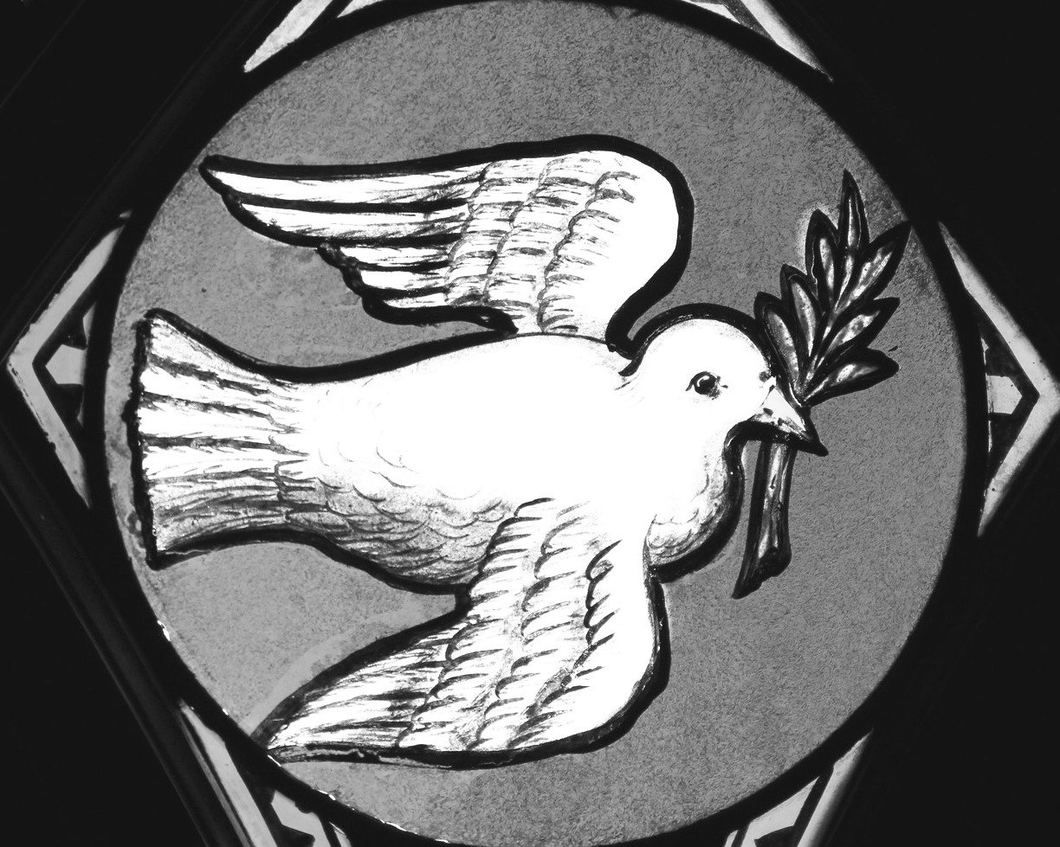

## Thank you for joining us today!

if you would like to receive our weekly e-bulletin, please contact the church office (aschurch@allsaintschelmsford.org) To learn more about us, visit https://www.allsaintschelmsford.org or call us at 978